THE AUSTRALIAN EVANGELICAL LUTHERAN CHURCH
DOWNS/MARBURG PARISHES
Easter 2020
A word from the Pastor:
Dear brothers and sisters in Christ,

May you all have a holy and blessed Easter Season. Sorry we can’t meet to worship together, but we remain united in the oneness of the Gospel, joined together by the death and resurrection of Jesus Christ. I pray that you are all well and are coping as best you can. Now is a good time to get out your Bibles and read the Gospel accounts of the death and resurrection of Jesus. All four Gospel accounts give wonderful insights into the Passion of Christ. Take the time to read and marvel at what Jesus accomplished for us on the cross. Reading the account of Jesus death and resurrection can give us so much comfort especially in a time of trouble like we find ourselves in today, struggling with a barrage of changes, of unanswered questions, of rough edges, of theological thoughts and concerns, of practical problems. Many face financial challenges. We struggle with moving targets, changing health regulations and mandates. We want more than to gather together as we receive the forgiveness and consoling power of the Word of the Gospel, the Scriptures, and the very body and blood of Jesus. We struggle trying to sort out how it is that the very coming together to receive Christ’s gifts may place us in danger. Some are lamenting and even distraught that because of quarantines, we have not been able to be at the bedside of treasured members of our church, or even to visit them in the nursing home.
However, we have Jesus; Jesus only, but that is sufficient. “My grace is enough for you. For My power is made complete when you are weak” (2 Cor. 12:9).
Let’s follow our Chief Shepherd into Jerusalem. With Him, let’s turn from false and misguided praise and expectations of earthly glory. Let us enter Holy Week with Jesus - humble and knowing that in this life, His way, our way, is the cross. “Take up [your] cross and follow Me” (Matt. 16:24). If Christ Himself ministered humbly through a cross, are we surprised when we must bear a few splinters?
On Monday, Jesus cleared the temple. The Law was on His lips. He said, “My house will be called a house of prayer, but you are making it a den of robbers” (Matt. 21:13). May the Lord scourge our hearts and chase out all that is unholy, uncharitable, ungodly and incompatible to the proclamation of His Gospel.
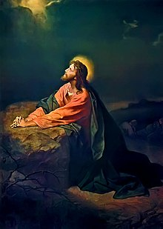
On Tuesday, our Lord was beset with the traps of the religious leaders. They questioned His authority, His view on taxes, on the resurrection, on who He is as the Son of God. O Lord, in the face of the onslaughts of the devil, the world and our flesh, grant that we cling to You and Your Word only! Help us be jars of clay.
On Wednesday, our Lord must have rested. Nothing is mentioned of His activity in the Gospels. O Lord, even You took time to step away for prayer and rest. Forgive us our lack of care for ourselves and our loved ones. Lord, grant us rest, if just for a little while, in the midst our many tasks and worries. Give us patience and love for our families.
On Thursday, our Lord prayed in the Garden, “…not My will, but Yours be done!” (Luke 22:42). End this scourge, O Lord. But if that is not Your will, use this plague for blessing as You used the suffering of Your holy cross for blessing. Many of us cannot now receive Your blessed gift of the Supper. Cause us to cling to Your Word of forgiveness and bring to mind the Gospel in the very Words of Institution: “Given and shed for you for the forgiveness of sins!” Bring our flock together soon around You!

On Friday, beaten and bloodied, You went the way of the cross. “Father, forgive them! For they do not know what they are doing” (Luke 23:34). This is how You spoke of those who crucified You. Grant us but a sliver of Your charity to those who sin against us. You said, “It is finished” (John 19:30). You have done the work. We are but heralds of the message, unworthy servants of the King. “However, we have this treasure in clay jars, with the result that this all-surpassing power comes from God and not from us. In every way we are hard-pressed but not crushed. We are perplexed but not in despair. We are persecuted but not forsaken. We are struck down but not destroyed” (2 Cor. 4:7–9).
On Saturday, our Lord’s body rested in the tomb. Cause us, O Lord, not to fear death nor the death of Your saints. Comfort us with the sure knowledge that death is but for our bodies a Holy Saturday of slumber, and for our souls, paradise with Christ. “Truly, I tell you, today you will be with Me in paradise” (Luke 23:43).

On Easter Sunday, early, the angel said, “He is risen! Go to Galilee, just as He said!” O Lord, raised for our justification, when You ascended, You gave good gifts to men, including the Office of the Ministry to Your Church. Give us Easter faith, joy and confidence, all to the service of Your blessed people, the church, that Your Gospel go forth on the lips of all, to all. In Your name, O Jesus, through the Holy Spirit, to the Father, Amen!
For our own safety and well-being, we refrain from regular congregational services. While we cannot gather together, we can use technology to stay in contact with each other. Telephone, email, social media - we can stay in touch with each other, pray for one another, and encourage each other with the Word of God.
I encourage you all to continue to follow the local guidelines regarding social distancing. The government is not persecuting us (Fourth Commandment). These rules apply to all, as reasonably as possible. And it appears we are nowhere near the end of this. “The primary form of the kingdom on the left is the family, which God has instituted for the welfare and stability of society. From this is derived the power of the state to protect the welfare of families on a larger scale (tribe, state, and country). As a power of God, the state has the responsibility to make and enforce laws that are for the good and mental and bodily welfare of its citizens, and not for their harm,” (Statement of Faith, Church and State, p. 49).
In these unprecedented times for us, there is great flexibility in how we respond to the needs of each other. (“Christ has freed us that we may be free” [Gal. 5:1]). We must show charity to each other, particularly in these stressful times. But I also urge love and patience toward all. “Above all, continue to love one another fervently! For “love covers a multitude of sins.”” (1 Peter 4:8). “For you have been called to be free, fellow-Christians. Only do not use your freedom to give your sinful nature a starting point but through love serve one another!” (Gal. 5:13).
We are in this together and, more importantly, Christ is together with us, to guide us by His blessed and inerrant Word. We are going to be OK! “May He not allow your foot to slip! Let Him who keeps you not fall asleep! Indeed, He who watches over Israel will neither fall asleep nor slumber. The LORD is your Keeper. The LORD is your Shade on your right hand” (Ps. 121:3–5).
Stay the course, dear friends! This is temporary, and we are learning things from the Word of God that we’d never thought we’d be paying much attention to!
Take care of yourselves and stay in the Word, and pray. Take comfort that Christ and His Spirit are praying for you! “In the same way, the Spirit also helps us in our weakness. For we do not know what we are to pray for as we ought to, but the Spirit Himself pleads for us with groanings that cannot be uttered. He who searches our hearts knows what the mind of the Spirit is. For the Spirit pleads for God’s holy people according to God’s will” (Romans 8:26-27).
“I shall ransom them from the power of Sheol. I shall redeem them from death. Death, where are your stings?” (Hos. 13:14).
May you all a holy and blessed Easter!

The Lord’s Supper in Private Homes
At one time, we were using social media to distance ourselves from each other in the home. Now, we are using the internet to connect with other homes during social distancing. Most of us are stuck at home. All of us have been asked by our government to stay away from the public gathering of the church. Thank God then that we have the technology to keep in touch with each other! Through the means of printed or recorded media, we are joined in mystical communion with one another. Oh yes, a hole has been made in our lives since we can’t meet together, but we are still taught to pray and say, “This the day that the LORD has made! Let us rejoice and be glad in it!” (Psalm 118:24). In these strange times, we have been given the opportunity to be creative and innovative in the proclamation of the Word of the Lord at our homes; however, we are not authorised to be imaginative and adventurous in the administration of the Lord’s Supper in our homes.
We find ourselves no longer in an ideal situation for receiving the Lord’s Supper. Having been asked to stay at home, we now find ourselves in a strange “Lenten Exile” from the liturgical life around the Lord’s Table, but it is not unprecedented. History is full of examples when the church could not meet or had to go without the Lord’s Supper for some time due to a number of things out of our control. But through all of this, the church continues to exist. The gates of hell will not prevail; the Word of Lord endures forever. In every age, the Gospel has been proclaimed through speaking, preaching, and writing, and this Gospel proclamation can and should be done on the internet making the most of visual and vocal means that have been made available to us. Of course, the Gospel proclamation can and also should be done in the home.
However, let us be careful that the imagination of our hearts does not lead us into a new idolatry. While churches have been asked to stop meeting together, the suspending of the Divine Service cannot result in home communing. The one thing that we cannot do in these awkward days is to become adventurous in the administration of the Lord’s Supper. We must not cause more chaos and dive into disorder regarding the receiving of Holy Communion. We must not encourage or engage in family communion services. Yes, we find ourselves now living in strange times, but we need to be careful lest we start strange practices that are foreign to the church universal.
In 1523, Martin Luther wrote a letter to the Hussites who had found themselves in an awkward situation. They were deceiving the pope with a false loyalty in order to obtain ordained pastors to provide the Lord’s Supper. Luther advised them to abstain from this deception and even the reception of the Eucharist. He wrote,
“…I would confidently advise that you have no ministers at all. For it would be safer and more wholesome for the father of the household to read the gospel and, since the universal custom and use allows it to the laity, to baptize those who are born in his home, and so to govern himself and his according to the doctrine of Christ, even if throughout life they did not dare or could not receive the Eucharist. For the Eucharist is not so necessary that salvation depends on it. The gospel and baptism are sufficient, since faith alone justifies and love alone lives rightly. Surely if in this way two, three, or ten homes, or a whole city, or several cities agreed thus among themselves to live in faith and love by the use of the gospel in the home, and even if no ordained man, shorn or anointed, ever came to them or in any other way was placed over them as minister to administer the Eucharist and other sacraments, Christ without a doubt would be in their midst and would own them as his church…” (Luther’s Works, 40:9-10).
Although the head of the household is responsible for the Biblical education of his home, he is not placed in the public office for the administrating of the public sacrament of Holy Communion. The sacrament of Baptism and the perpetual use of the Gospel in speaking and writing is sufficient for salvation. Furthermore, Luther compares the strange times of the Reformation to the days of the Babylonian Exile. He writes,
“…The father in the home, on the other hand, can provide his own with the necessities through the Word and in pious humility do without the nonessentials as long as he is in captivity. In this regard we follow the custom and law of the Jewish captives who were not able to be in Jerusalem or to make offering there. Upheld in their faith alone by the Word of God they passed their lives among enemies while yearning for Jerusalem. So in this ease the head of the household suffering under the tyranny of the pope would act most appropriately and safely if while longing for the Eucharist, which he neither would dare nor could receive, in the meantime zealously and faithfully propagated faith in his home through the Word of God until God on high in his mercy either brought the captivity to an end or sent a true minister of the Word…” (Luther’s Works, 40:10).
Although our days are drastically different, we do have ordained pastors, but the state is telling us to stay away from each other. Nevertheless, the advice of Luther regarding the administration of the Lord’s Supper can still be heeded during any exceptional circumstance. What could possibly be at least a six-month ban is nothing compared to 70 years in Babylon. When the Temple was destroyed, the people of God were not able to gather at the altar in Jerusalem. They were in exile. Yet, the Word of our God will endure forever (Is. 40:8).
In 1536, Luther wrote specifically on the topic “Concerning House Communion.” In a letter addressed to Wolfgang Brauer, he wrote,
“…Kindly tell your dear sir and friend that he is not in duty bound to go ahead in this matter and give Holy Communion to himself and his household. Nor is this necessary since he is neither called nor commanded to do this. And if the tyrannical ministers will not administer it to him and his family, thought they should do it, yet he can be saved by his faith through the Word. It would also give great offence to administer the Sacrament here and there in the homes, and in the end no good would come of it, for there will be factions and sects, as now the people are strange and the devil is raging… …But if a father wishes to teach the Word of God to his family, that is right and should be done, for it is God’s command that we should teach and bring up our children and household; that is commanded to everyone. But the Sacrament [of the Altar] is a public confession and should be administered by public ministers…”
Again, note that Luther is clear here. There is no such thing as home communing. Holy Communion is a public sacrament to be administered by a man in the public office of preaching. In the household, the Word of the Lord is to be used by the father to teach the family.
In C. F. W. Walther’s Pastoral Theology, he addresses the issue of a layman administering the Lord’s Supper by looking to the theologians of the church rather than setting up innovative ideas. He states,
“The great majority of our theologians, Luther in the forefront, believe that the holy Supper should never be administered privately by one who is not in the public preaching office, by a layman. That is partly because no such necessity can occur with the holy Supper, as with Baptism and Absolution, that would justify a departure from God’s ordinance (1 Cor. 4:1; Rom. 10:15, Heb. 5:4); partly because the holy Supper “is a public confession and so should have a public minister”; partly because schisms can easily be brought about by such private Communion.”
Our own AELC Statement of Faith speaks much the same thing under the heading Lay Consecration.
Walther goes on to quote Johann Gerhard, “…[W]e by no means approve of disorder in the church and ascribe to no one the power to administer the holy Supper except to him who has been legitimately called, not even in an emergency, since Baptism and the holy Supper are in a different relationship.” Even if these strange times could be deemed an emergency or exceptional circumstances, we must not fail to remain diligent, and must not theologically distance ourselves from our dogmaticians, or indeed, what the Word of God has to say.
So it is, based on Scripture and our Lutheran theologians, since the time of the Augsburg Confession, we believe, teach, and confess that the Lord’s Supper should not be administered by a man who does not hold the office. Although a house father should lead his house in hearing the Word, he should not steer his family into home communing. While we wait for the ban to be lifted and use innovative ways to proclaim the Word of the Lord from our homes; let us not fall into the temptation of becoming impatient and take the bait of having communion services in our homes.

New Zealand PM rushes world’s most extreme abortion legislation into law while country distracted with pandemic
New Zealand MPs have introduced the most extreme abortion law in the world after the Abortion Legislation Bill passed its third reading in Parliament.
The bill passed by 68 votes to 51 – a much narrower margin than at the first and second reading.
The new law will mean that New Zealand has the most extreme abortion law in the world, this will include:
Abortion will now be available on-demand, for any reason, up to birth
Sex-selective abortion will be legalised
The current 20-week limit for disability-selective abortion will be scrapped and abortion will be available up to birth for disabilities including cleft lip, club foot and Down syndrome
There will be no requirement that a doctor must be involved with providing an abortion
There will be no legal requirement that babies born alive after a ‘failed’ abortion are given medical support
There will be no legal requirement that pain relief be given to babies being aborted between 20 weeks and birth
There will be no legal restrictions on controversial methods of abortion such as intact dilation and extraction abortions (also known as partial-birth abortions)
Polling shows that the new law is strongly opposed by the public in New Zealand and in particular by women, with only 2% of women supporting abortion being available on-demand up to birth, 93% of women opposing sex-selective abortion being legal and 94% of women supporting the current legal standards for abortion providers and premises.
Given the extremely low public support for the change and that the gap between MPs opposing and supporting was quickly closing, Jacinda Ardern’s Government rushed the final stages of the Bill’s progress through Parliament while MPs, media and the country were distracted with dealing with the Coronavirus pandemic. This included progressing the final sitting of the committee stage and the Bill’s third and final reading through Parliament on the same day.
The Bill has also seen a very large backlash from the disability community with over 1,200 people with Down syndrome and their families calling on the Prime Minister, Jacinda Ardern, to keep a pre-election promise to not introduce abortion up to birth for Down syndrome.
An amendment hoping to put the issue to a public referendum failed in a conscience vote by 100 votes to 19 votes, denying the public a final say on the legislation.
Additionally, the Abortion Legislation Committee only heard from 139 people who wanted to give oral feedback on the Bill, despite over 25,000 submissions.
By way of comparison, the Climate Change Response (Zero Carbon) Amendment Bill received just 10,000 written submissions, but the Environment Committee heard 1,500 oral submissions.
New Zealand Prime Minister, Jacinda Ardern, was among 80 MPs responsible for defeating an attempt to require healthcare professionals to give medical help to babies born alive after ‘failed’ abortions.
An attempt to protect babies from sex-selective abortion was defeated with 50 votes in favour and 70 against, despite strong concerns over the practice being highlighted in a submission to the Abortion Legislation Committee from Stop Gendercide – a campaign group who had urged MPs to support the amendment.
Other defeated pro-life measures, aiming to soften the scope of the Bill, included pain relief to babies being aborted between 20-weeks and birth, stronger protections to conscientious objection and requiring the collection of abortion statistics.
Over 60,000 people signed a petition calling on New Zealand deputy-Prime Minister, Winston Peters, to ensure the Government withdrew the Bill.
The Green Party failed in its attempt to reverse a mistake that resulted in criminalised free speech zones, which prevent pro-life help from being offered outside abortion clinics, being excluded from the legislation.
Green Party co-leader Marama Davidson had attempted to reintroduce the measure but MPs voted 77 to 43 against it.
New Zealand-based pro-life campaign group Voice for Life said: “In passing Labour’s extreme abortion Bill our MPs have ushered in a new law that will liberalise abortion up to birth, allow for sex-selective abortions, and remove current freedom of conscience rights from New Zealand medical professionals.
“Over the last few Parliamentary sessions our MPs had the opportunity to pass amendments that would have corrected some of the worst extremes of this Bill but instead they chose to reject such moderate measures…
“Our Parliament has a duty of care to consider the wellbeing and protection of all New Zealanders including the vulnerable.
“Tonight they failed in that basic duty of care by passing this extreme Bill, but the hundreds of thousands of voters who opposed this Bill will not forget this failure when it is time to vote in the General Election in a few short months.”
And He Shall Reign Forever and Ever
“The Kingdom of this world is become the kingdom of our Lord and of His Christ” the choir sang. King George II, moved by the music, stood and with him all the audiences from that day forward to the present — or so the legend goes. These words from Scripture set in the form of a liturgical gospel verse captures a profound truth. No matter how evil and chaotic the world looks, God’s kingdom rules the universe.
So, why does Jesus have us pray: “Thy kingdom come?” Luther explains that God’s kingdom comes whether or not we pray for it. But we pray that it will come to us. Jesus Himself suggests this when He sums up His message: “the kingdom of heaven is here! Repent (literally: change your mind completely) and believe the good news.”
God’s kingdom comes to us in two ways. First, when God the Holy Spirit plants faith in our hearts, we believe that our sins are forgiven because of the sacrifice of Jesus on the cross. We turn away from our sins and desire to live according to His Word. We do this together with all our fellow citizens of His kingdom. Our prayer is that God will give us the strength to live this way.
The second way the kingdom comes when, on the day known only by the Heavenly Father, Jesus returns with His angels to bring an end to sin, disease, grief and death, to open the graves of all people, raise them from death and bring them before His throne. On that day, all will be set right, the devil, His angels and unbelievers cast into hell and God’s children go to live with Him forever. Then He will reign forever and ever.

Whose Church?
“You are Peter, and on this rock I shall build My church, and the gates of Hades will not overpower it.” (Matthew) 16:18.
We live in a time where many no longer want to talk about building up the church, but instead about its gradual disintegration/decay. In many countries the church is actually experiencing a decline in numbers, influence, and in vitality. Will she survive this time? That’s a question that you can ask yourself everywhere.
The answer depends upon whether one is talking about
the organisation or buildings, or the “communion of saints.” The church which will assert itself against hell’s forces; it doesn’t depend upon anyone, not even Peter, but will exist where one remains faithful to the confession: “You are the Son of the living God.”
Many traditions of the church change themselves. The scaffolding that is very often used for the church has to be disassembled, so that Christ can be worshipped in the middle. This development is unstoppable. Luther explained: “. . . upon the confession of the faith, which
makes you into a rock, that’s where I want to build my
church. This foundation can hold and is strong enough,
the devil will not be able to push and tear it down.”
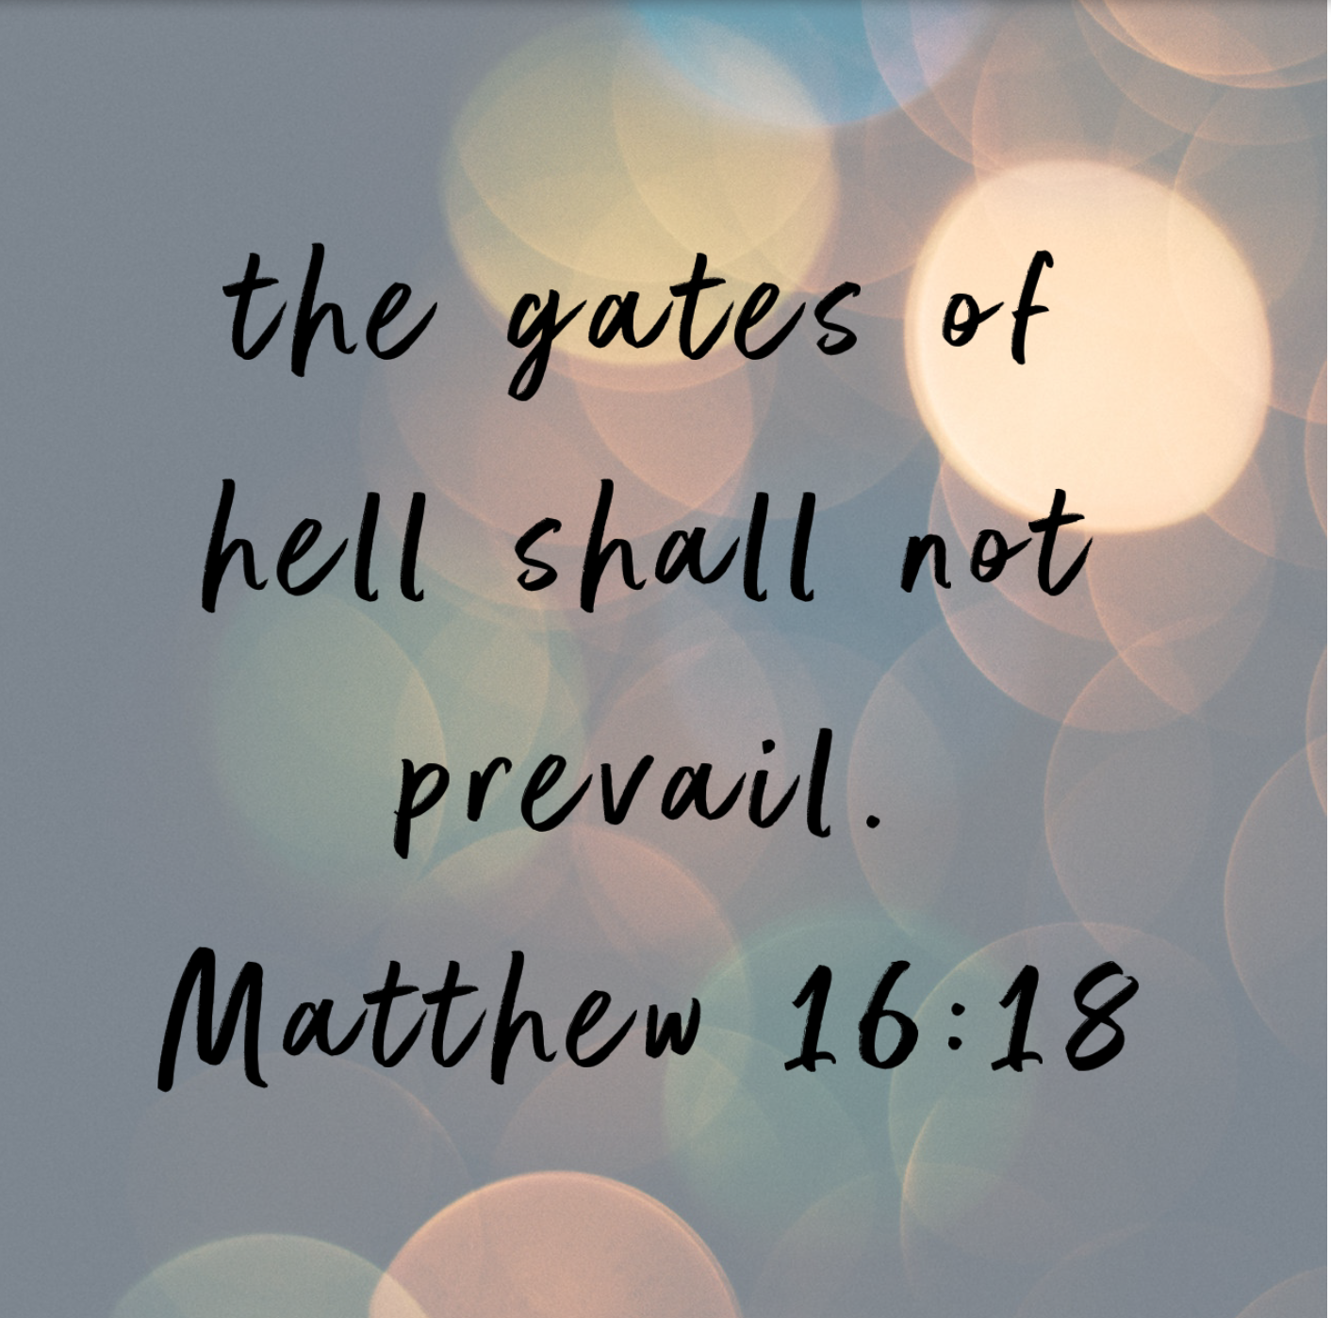
Lord Jesus, sustain Your church. Don’t let the gates of hell overpower it. Amen.

Every year for the Downs Parish Easter Picnic, held at Aubigny, we always have a colouring-in competition for the children, with prizes given over different age groups. Even though we are not meeting this year, let’s still have a competition!!! Kid’s, print out the picture on the next page, colour it in, and send it to me by the 26th of April. I’ll find some prizes to hand out. Don’t forget to write your name and age.
Send to: Pastor Ziebell, 34 Fitzpatrick Street, Toowoomba, 4350.
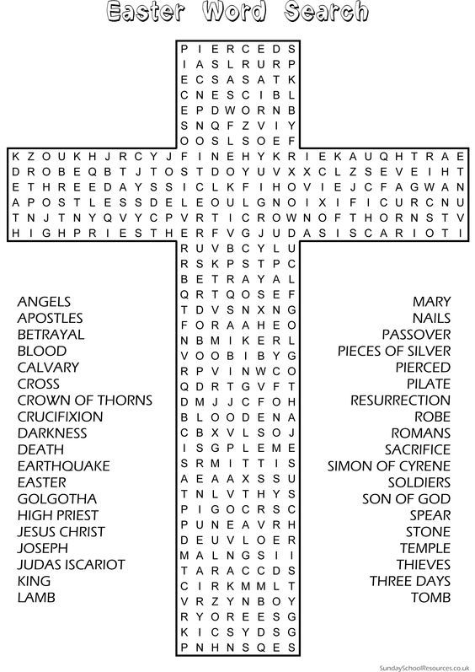

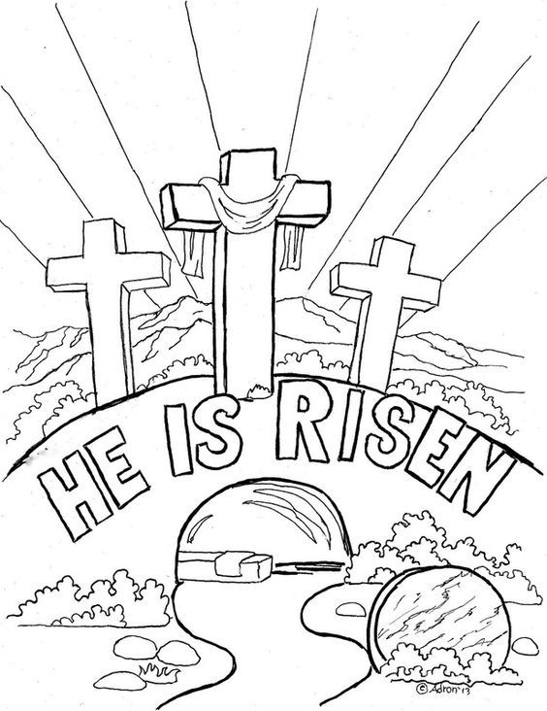

As quoted by C. F. W. Walther in Church and Ministry, CPH, 1987, p. 173 from Luther’s letter written to Wolfgang Brauer, 1536, St. Louis edition, 10:22-25
C. F. W. Walther, American Lutheran Pastoral Theology, trans. John M. Drickamer (New Haven, Missouri: Lutheran News, Inc., 1995), 134.

